Wall Ball Workouts
Villanova Women’s Lacrosse

WORKOUT #1
** (count drops/ time yourself!)**
• 50 Right (Catch, Cradle)
• 50 Left (Catch, Cradle)
• 50 Quick stick right
• 50 Quick stick left
• 50 Catch right, throw left
• 50 Catch left, throw right

WORKOUT #2
**Positioning: 8- 10 yards off the wall. Everything is caught off a bounce**
• 25 R Catch, cradle, throw
• 25 L Catch, cradle, throw
• 20 total – throw, catch, switch. (10 throws left, 10 throws right)
• 20 R bounce pass against wall for high ball in air, one hand catch
• 20 L bounce pass against wall for high ball in air, one hand catch

WORKOUT #3
• 25 right (catch, cradle, throw) ** Vary your cradle**
• 25 left (catch, cradle, throw) ** Vary your cradle**
• 15 double switches R
• 15 double switches L
• 10 dip n dunk (fake high, fake low, explode up throw) R
• 10 dip n dunk (fake high, fake low, explode up throw) L
• 15 back hand throws R (don’t flip wrists over)
• 15 back hand throws L (don’t flip wrists over)
• 25 quick stick R
• 25 quick stick L

WORKOUT #4
• 25 over hand R
• 25 over hand L
• 25 side arm R (hip level)
• 25 side arm L (hip level)
• 25 risers R (release point is low by knee, snapping all the way through high)
• 25 risers L (release point is low by knee, snapping all the way through high)
• 10 hitch high, side arm R
• 10 hitch high, side arm L

WORKOUT #5 ** For time, 2 rounds!*
• 10 Righty
• 10 Lefty
• 10 Righty
• 10 Lefty
• 10 Off side right
• 10 Off side left
• 10 Off side right
• 10 Off side left
• 10 Catch right switch left
• 10 Catch left switch right
• 10 Catch right switch left
• 10 Catch left switch right

WORKOUT #6
• 20R
• 20L
• 20 catching switching (Catch R switch throw L, catch L, switch throw R)
• 20 passing switching (changing hands when ball is in air)
• 10 back hand R
• 10 back hand L
• 10 quick stick R
• 10 quick stick L
• 5 1 handed throws R
• 5 1 handed throws L

WORKOUT #7
• 25R
• 25L
• 25 off stick R
• 25 off stick L
• 25 catch switch (R-L/ L-R)

WORKOUT #8
** Wrist workout**
• 10 one handed right
• 10 one handed left
• 5 one hand hitch , throw R
• 5 one hand hitch, throw L
• 20 off stick switch without ball (10- right, 10- left)
• 10 catch right, one hand drop to spot 6 throw (left hand with the touch)
• 10 catch left, one hand drop to spot 6 throw (right hand with the touch)
• 10 (5 each hand) spot 3 to 6 throw (5- right, 5-left)

CRADLING
Villanova Women’s Lacrosse
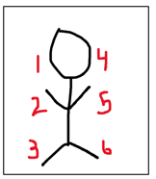
Cradling Sequence Stationary #1 (Don’t need to pass on wall)
** Each set 5 times each **
• Spot 1 to Spot 5 righty
• Spot 1 to Spot 5 Lefty
• Spot 2 to Spot 6 righty
• Spot 2 to Spot 6 lefty
• Spot 4 to Spot 3 righty
• Spot 4 to Spot 3 lefty
• Spot 1 to Spot 5 to Spot 3 righty
• Spot 1 to Spot 5 to Spot 3 lefty
• Spot 4 to Spot 2 to Spot 6 righty
• Spot 4 to Spot 2 to Spot 6 lefty

Cradling Sequence #2 (Against wall)
**Cradling and passing on the move**
• Throw right catch right
• Drop step 5 yards
• On way back hit spot 1&5 on the move
• Throw right catch right
• Drop step 5 yards
• On way back hit spot 4&3 on the move
• Throw left catch left
• Drop step 5 yards, On way back hit Spot 1&5 on the move
• Throw left catch left
• Drop step 5 yards
• On way back hit spot 4 to 3 on the move
• Drop step 5 yards
• On way back hit spot 4 to 2 hitch on the move
• Drop step 5 yards
• On way back hit spot on spot 3 to 6 hitch
• Drop step 5 yards
• On way back hit spot 4 to 2 hitch on the
• Drop step 5 yards
• On way back hit spot 3 to 6 hitch on the move

DODGING
- Find a dummy defender- a cone, ball bag, sibling..
- Work on all dodges- face, split, roll, rocker.
- Start dodges slower to work on footwork. Gradually increase the speed of the dodge until you are comfortable doing it at top speed.
- Make sure to dodge using both hands. For example, you should practice rolling right to left AND left to right.
- Increase difficulty (and make it your own) by adding a stutter step or other footwork before the dodge.
Right Alley & Left Alley Dodge & Shot:
Villanova Women’s Lacrosse
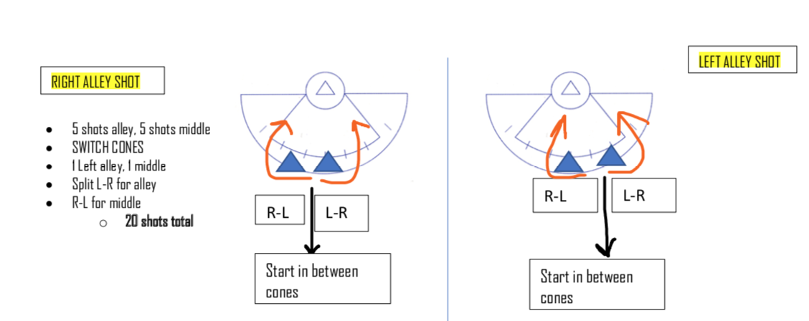

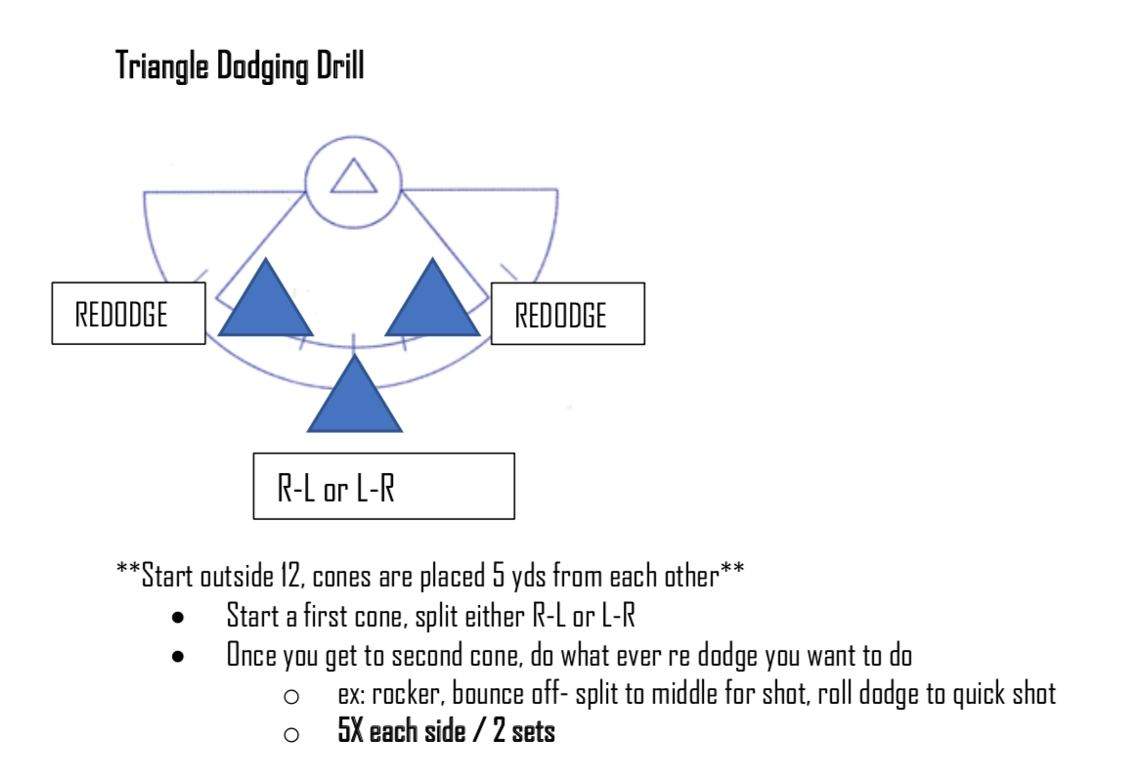
DODGING IMPORTANT NOTES:
- Always remember to keep your stick protected and out of range of a defender’s check.
- Cut off the defender immediately after the dodge- don’t veer right or left because that is where the defense slides are coming from.
- Start the dodge one stick’s length away from the defender to allow yourself space to complete the dodge.

CONDITIONING WORKOUTS
Run #1: 300s for time
· Start on endline
· Run up to the restraining line and back to the endline 3 times (up, back, up, back, up, back)
· Do this for 3 rounds, with one-minute rest between each round
** Try to get each 300 under 70 seconds**
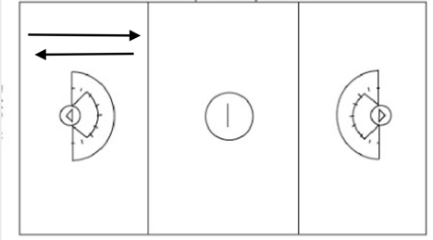
Run #2: Sprint-Jog for 5 mins
· Start on corner of field
· Sprint on Blue lines
· Jog on Red lines
· Do this for 2 round, with 1:30min break between rounds
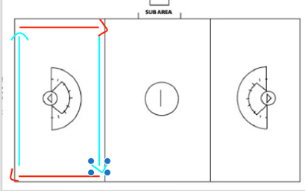

Run #3: Gassers for time
· Start on sideline
· Run up to opposite sideline, and back 4 times (up, back, up, back)
· Do this for 5 round, with 1 min rest between rounds
**Aim to get each round under 50 seconds**
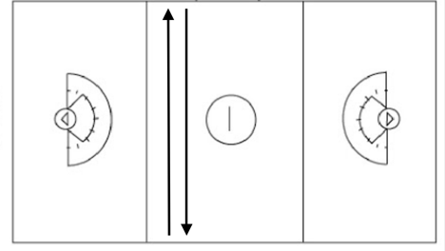

Run #4: Treadmill Sprints for 10 minutes
· Warm up with a 2-minute jog (speed set: 3-4mph)
· For 6 minutes- Sprint for 20 seconds (speed set: 6-7mph), jog for 10 seconds (speed set: 3-4mph)
· Cool down with 2-minute jog (speed set: 3-4mph)

